Course Name : PG Diploma in Advanced Computing
Batch : August 2019
Module Name : Advanced Web Programming Date :

Student Name : PRN No :
Max Marks : 40 Marks
Duration : 2 Hour

Create an html5 page for feedback form as shown in below image. (30 Marks)
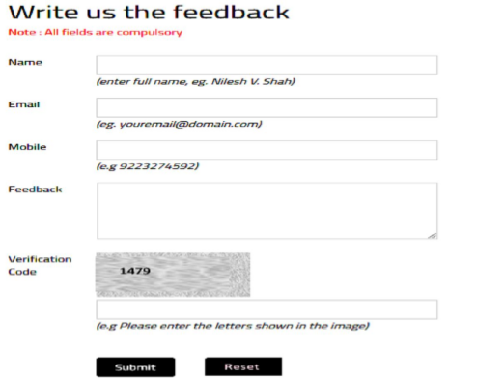

Display heading in h2 in blue color,

Use CSS to display error messages in red color and use JavaScript for validation.

All fields are mandatory, Numbers are not allowed in name

EmailID, contact number validations are required.

Feedback message length should be only 150 char.

Provide random alphanumeric captcha for verification.

Provide a red background color and white text color to the captcha.

On reset click, reset all fields.

Display registration successful message after clicking submit button.

Evaluation of Lab Exam should be based on the following criteria:
Criteria | Details | Max Marks | Marks Obtain
Algorithm | Documentation of Algorithm and Flowchart | 30
Algorithm | Program adheres to the algorithm and flowchart | 30
Efficiency | Program is using only the required number of variables  /conditions/loops/pointers etc and is optimal | 30
Correctness | The program produces desired output for a given input | 30
Correctness | The program handles all valid and Invalid inputs | 30
Software Engineering Principles | The program has meaning variable/function names | 30
Software Engineering Principles | The program is commented properly (At least 20% of the code should be commented) | 30
Viva |  | 10
 | Total Marks | 40

Signature of Student Signature of Evaluator Signature of Coordinator

Course Name : PG Diploma in Advanced Computing
Batch : August 2019
Module Name : Advanced Web Programming Date :

Student Name : PRN No :
Max Marks : 40 Marks
Duration : 2 Hour

1. Create a User Registration Form and Ask user to input below details (30 Marks)

a. User Firstname

b. User LastName

c. User Gender

d. User Education

e. User Telephone Number

f. User email id

g. User Country of Residence

h. User Interests

i. User Work Experience

j. Submit Button and Reset Button

- Display heading “User Registration” in h1 in brown color using CSS.
- Use bootstrap to design form
- JavaScript Validation from Firstname, Lastname,Gender, Education and EmailID
- Display error in case user experience is less then 1 year
- Create a User table in database
- After clicking on submit button, insert data into the User table and display data inserted successfully message.

Evaluation of Lab Exam should be based on the following criteria:
Criteria | Details | Max Marks | Marks Obtain
Algorithm | Documentation of Algorithm and Flowchart | 30
Algorithm | Program adheres to the algorithm and flowchart | 30
Efficiency | Program is using only the required number of variables  /conditions/loops/pointers etc and is optimal | 30
Correctness | The program produces desired output for a given input | 30
Correctness | The program handles all valid and Invalid inputs | 30
Software Engineering Principles | The program has meaning variable/function names | 30
Software Engineering Principles | The program is commented properly (At least 20% of the code should be commented) | 30
Viva |  | 10
 | Total Marks | 40

Signature of Student Signature of Evaluator Signature of Coordinator

Course Name : PG Diploma in Advanced Computing
Batch : August 2019
Module Name : Advanced Web Programming Date :

Student Name :
Max Marks : 40 Marks

PRN No :
Duration : 2 Hour

(30 Marks)

1. Create a Add Product Form

a. ProductName

b. Product Category (DropDown)

c. Product Price

d. Product Expiry Date

e. Product Identifiation number

f. Product Supplier(Wholesale or Retail)

g. Product quantity

h. Product Supplier Address (TextArea)

i. Product image

j. Submit Button and Reset Button

Apply JavaScript validations:

Product name, product category, product price, product identification number are mandatory

In product identification number, No special characters are allowed

Display error in case product price is less then 0 or equal to 0

After checking all the validation on clicking Submit button insert all data into product table in the database using PHP and redirect to ViewProduct page.

ViewProduct page will display all the products in tabular form.

Evaluation of Lab Exam should be based on the following criteria:

Criteria | Details | Max Marks | Marks Obtain
Algorithm | Documentation of Algorithm and Flowchart | 30
Algorithm | Program adheres to the algorithm and flowchart | 30
Efficiency | Program is using only the required number of variables  /conditions/loops/pointers etc and is optimal | 30
Correctness | The program produces desired output for a given input | 30
Correctness | The program handles all valid and Invalid inputs | 30
Software Engineering Principles | The program has meaning variable/function names | 30
Software Engineering Principles | The program is commented properly (At least 20% of the code should be commented) | 30
Viva |  | 10
 | Total Marks | 40

Course Name : PG Diploma in Advanced Computing
Batch : August 2019
Module Name : Advanced Web Programming Date :

Student Name :
Max Marks : 40 Marks

PRN No :
Duration : 2 Hour

Create a website for car dealer having various company cars. (30 Marks)

It should have a single background image of car. Scale the background image to be as large as possible so that the background area is completely covered by the background image.

Provide links for customer registration, car gallery on main page.

Create customer registration html page as shown below and css which should do the following:

Display heading in h1 in blue color, Display link in brown without underlying them

When the mouse hovers over the link, change the link’s background color to yellow, and text’s color to blue.

Provide appropriate validation for all fields.

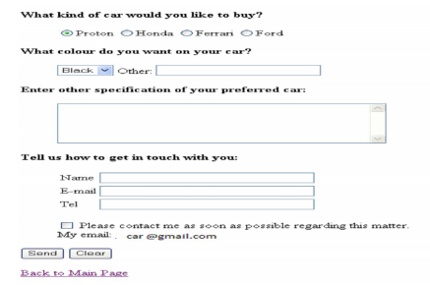

Evaluation of Lab Exam should be based on the following criteria:

Criteria | Details | Max Marks | Marks Obtain
Algorithm | Documentation of Algorithm and Flowchart | 30
Algorithm | Program adheres to the algorithm and flowchart | 30
Efficiency | Program is using only the required number of variables  /conditions/loops/pointers etc and is optimal | 30
Correctness | The program produces desired output for a given input | 30
Correctness | The program handles all valid and Invalid inputs | 30
Software Engineering Principles | The program has meaning variable/function names | 30
Software Engineering Principles | The program is commented properly (At least 20% of the code should be commented) | 30
Viva |  | 10
 | Total Marks | 40

